Projectile W.S.
- Use the scale 1 cm = 5 m, list in the table provided the vertical positions of a ball dropped from rest at 1-second intervals. Neglect air resistance and assume g = 10 m/s². When the ball is no longer in the air, enter NA into the forms provided.

- The first column states the time in seconds.
- The second column states the ball's instantaneous displacement from the top of the cliff.

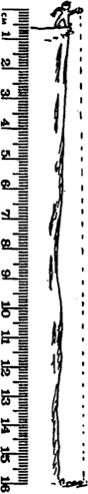
TIME (sec) _INST. Displ. (meters)
1.0 sec
2.0 sec
3.0 sec
4.0 sec
5.0 sec
6.0 sec

  - When you "mentally" connect the ball's positions with a smooth curve to show its path, what is the path's shape?

- The first four horizontal positions of the thrown ball with no gravity are plotted at 1-second intervals. Using the scale, 1 cm = 5 m, along with the facts that air resistance can be neglected and g = 10 m/s², list both the horizontal and vertical positions of the ball at the end of each 1- second interval.

- The first column states the time in seconds.
- The second column states the ball's instantaneous vertical displacement from the top of the cliff.
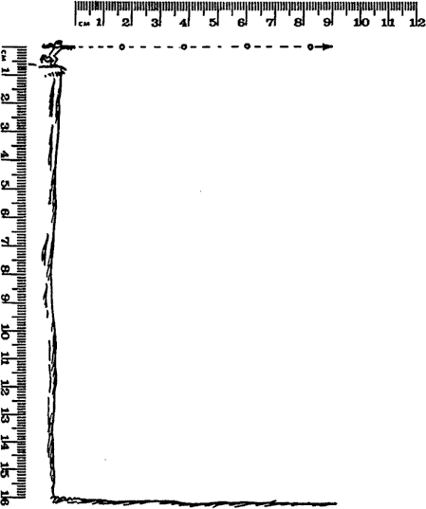
- The third column states the ball's instantaneous horizontal displacement from the edge of the cliff.

T(sec) v.dspl (m) h.dspl (m)

- When you "mentally" connect the ball's positions with a smooth curve to show its path, what is the path's shape?

- How is the motion in the vertical direction affected by the motion in the horizontal direction?

- This time the ball is thrown below the horizontal. Using the same scale, 1 cm = 5 m, along with the facts that air resistance can be neglected and g = 10 m/s², list both the horizontal and vertical positions of the ball at the end of each 1-second interval.

- The first column states the time in seconds.
- The second column states the ball's instantaneous vertical displacement from the top of the cliff.
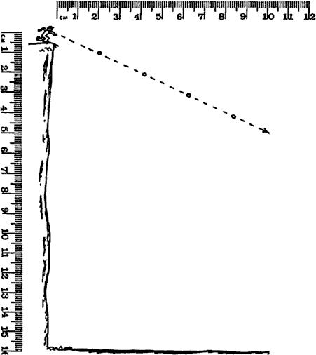
- The third column states the ball's instantaneous horizontal displacement from the edge of the cliff.

T(sec) v.dspl (m) h.dspl (m)

a. When you "mentally" connect the ball's positions with a smooth curve to show its path, how does its shape differ from that created in the previous question?

Estimate the number of seconds the ball remains in the air.

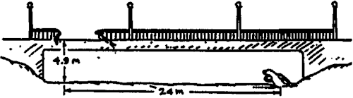
4. Refer to the following information for the next question.

Suppose that you are an accident investigator and you are asked to figure out whether or not the car was speeding before it crashed through the rail of the bridge and into the mudbank as shown. The speed limit on the bridge is 55 mph = 24 m/s.
What is your conclusion?

traveling slower than the speed limit
traveling at the speed limit
traveling faster than the speed limit
- The boy on the tower throws a ball 20 meters downrange as shown.

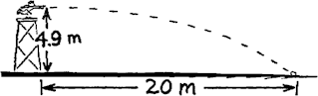

What is his pitching speed?
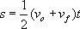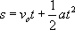

- Refer to the following information for the next five questions.
To start this problem, construct an H | V Chart and list your givens. Complete each calculation under the appropriate column. Do your work neatly and box in each answer with its appropriate unit of measurement.
A softball rolls off a 95-centimeter tall table. It strikes the floor 80 centimeters from the
base of the table.

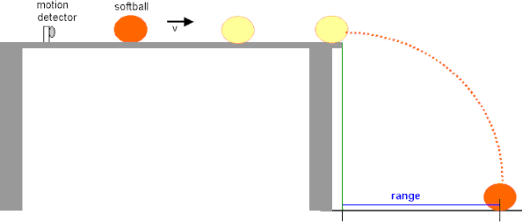
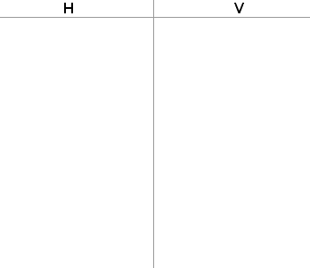
a. What information belongs in each column?

b.. How much time does it spend in the air? (Find t in the vertical column.)

c. How fast did it roll off the table? (Find v_{H} in the horizontal column.)

d.. How fast was it traveling vertically when it hit the floor? (Find v_{f} in the vertical column.)

e. What was its impact speed when it impacted the floor? This is asking you to calculate v_{R}, the resultant velocity.

Refer to the following information for the next five questions.
To start this problem, construct an H | V Chart and list your givens. Complete each calculation under the appropriate column. Do your work neatly and box in each answer with its appropriate unit of measurement.

A student tosses a coin into the pool of a nearby fountain. The coin travels 5 meters forward while taking 1 second before it impacts the water.

- What information belongs in each column?

- How fast was the coin released horizontally through the air? (Find v_{H} in the horizontal column.)

- How high above the top of the fountain's pool did the student release the coin? (Find s in the vertical column.)

- How fast was the coin falling vertically just before it struck the water? (Find v_{f} in the vertical column.)

- What was the coin's impact speed, resultant velocity, when it initially entered the water? (Find v_{R} the resultant velocity.)

Refer to the following information for the next five questions.
To start this problem, construct an H | V Chart and list your givens. Complete each calculation under the appropriate column. Do your work neatly and box in each answer with its appropriate unit of measurement.

An Olympic diver springs forward off a 10 meter platform. He enters the water 8 meters beyond the edge of the platform.

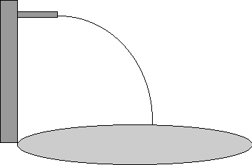

  - How much time does it spend in the air?

  - How fast did he spring forward off the edge of the diving tower?

  - How fast was it traveling vertically when it hit the water?

d.. What was its impact speed when it impacted the water?

e. At what angle did he enter the water?

9 Refer to the following information for the next six questions.

To start this problem, construct an H | V Chart and list your givens. Complete each calculation under the appropriate column. Do your work neatly and box in each answer with its appropriate unit of measurement.

A helicopter drops a relief package to some isolated refugees. The package travels 250 meters forward while taking 4 seconds to land after it is released.
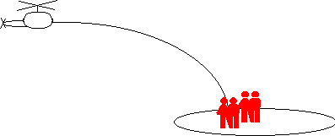

a. How high was the helicopter flying when it released the package?

b.. How fast was the helicopter flying when it released the package?

c.. How fast was the package falling vertically just before it landed on the island?

d.. What was the package's impact speed, resultant velocity, when it landed on the island?

e.. At what angle was the package's trajectory with respect to the ground at the instant that it landed?

f. If the helicopter pilot does not change his velocity after releasing the package, what will be the position of the helicopter when the package lands?
- A zookeeper devises a rubber band gun to shoot food to a monkey who is too shy to come down from the trees.

  - If the monkey does not move, should the keeper aim above, at, or below the monkey?

  - If the monkey lets go of the branch that it is holding at the instant the keeper shoots the food, should the keeper aim above, at, or below the monkey to get to the monkey in mid air?

Refer to the following information for the next seven questions.

A projectile is released at an angle of 37º above the horizontal at a speed of 15 m/sec.
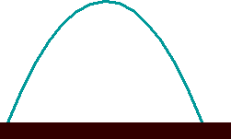

  - What are the horizontal and vertical components of its original release velocity?

  - How much time does the projectile spend rising to its apex?

  - How high is its apex above the release position?

  - How fast is it moving as it passes through its apex?

  - How much total time does it spend in the air?

  - What is its final range?

What is its resultant impact velocity and angle of impact just as it is about to strike the ground?

Refer to the following information for the next seven questions.

A projectile is released at an angle of 53º above the horizontal at a speed of 15 m/sec.

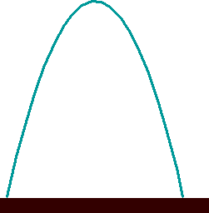

  - What are the horizontal and vertical components of its original release velocity?

  - How much time does the projectile spend rising to its apex?

  - How high is its apex above the release position?

  - How fast is it moving as it passes through its apex?

  - How much total time does it spend in the air?

  - What is its final range?

  - What is its resultant impact velocity and angle of impact just as it is about to strike the ground?

Refer to the following information for the next seven questions.

A projectile is released at an angle of 45º above the horizontal at a speed of 15 m/sec.
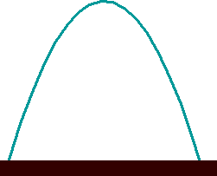

  - What are the horizontal and vertical components of its original release velocity?

  - How much time does the projectile spend rising to its apex?

  - How high is its apex above the release position?

  - How fast is it moving as it passes through its apex?

  - How much total time does it spend in the air?

g. What is its final range?

h. What is its resultant impact velocity and angle of impact just as it is about to strike the ground?
14. Refer to the following information for the next six questions.

Using the results of the three previous question groups, rank each of the following properties of projectiles that when they are released at a common speed but at different angles.

- Rank the initial vertical velocity of these three projectiles (37º, 45º, 53º) from greatest to smallest.

- Rank the time spent in the air of these three projectiles (37º, 45º, 53º) from greatest to smallest.

- Rank the initial horizontal velocity of these three projectiles (37º, 45º, 53º) from greatest to smallest.

- Rank the range of these three projectiles (37º, 45º, 53º) from greatest to smallest.

- Rank the height of apex of these three projectiles (37º, 45º, 53º) from greatest to smallest.

- Rank the resultant, impact velocity of these three projectiles (37º, 45º, 53º) from greatest to smallest.

- REVIEW: The speed of an airplane relative to the ground is affected by wind. When an airplane flies in the direction of a wind (tailwind), it has a greater groundspeed. When an airplane flies directly into a wind (headwind), it has a smaller groundspeed. Suppose an airplane is blown off-course by a 90-degree crosswind (keeping the nose pointing in a direction perpendicular to the wind direction). Will its groundspeed be more, less, or the same as in still air?

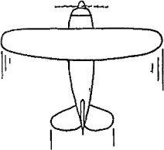

REVIEW: Refer to the following information for the next nine questions.
A water-filled balloon is dropped from the top of a building that is 50 meters above the ground. One second later, a rock is thrown upwards from the ground at the base of the building with an initial velocity of +15 m/s.
To simplify your calculations, you may use g = 10m/s² and the fact that there is no air resistance acting on the balloon as it falls through the air.

  - What is the gap between the balloon and the rock at the instant the rock is released?

  - How fast was the balloon traveling at the moment when the rock was released?

  - How much time passed after the balloon was released before it was struck by the rock?

  - What was the balloon's displacement before it was struck by the rock?

  - What was the rock's displacement before it struck the balloon?

  - What was the balloon's velocity at the instant it was struck by the rock?

  - What was the rock's velocity at the instant it struck the balloon?

  - Was the rock rising or falling when it struck the balloon? Who really struck whom?

  - Sketch (using general shapes) and then describe the position-time and velocity-time graphs for this problem. Circle on your position-time graph where the two projectiles collide.
